Predicting Financial Loss from Cybersecurity Incidents Using Machine Learning

Laith Kallab
Dept. Electrical and Computer Engineering – Faculty of Engineering
University of Western Ontario
London, Canada
lkallab@uwo.ca
Grace Neville
Dept. Electrical and Computer Engineering – Faculty of Engineering
University of Western Ontario
London, Canada
gnevill@uwo.ca
line 1: 4th Given Name Surname
line 2: dept. name of organization
(of Affiliation)
line 3: name of organization
(of Affiliation)
line 4: City, Country
line 5: email address or ORCID
line 1: 2nd Given Name Surname
line 2: dept. name of organization
(of Affiliation)
line 3: name of organization
(of Affiliation)
line 4: City, Country
line 5: email address or ORCID
line 1: 3rd Given Name Surname
line 2: dept. name of organization
(of Affiliation)
line 3: name of organization
(of Affiliation)
line 4: City, Country
line 5: email address or ORCID

Abstract— This project investigates the use of machine learning techniques to predict financial losses resulting from cybersecurity incidents. Using a publicly available dataset containing features such as attack type, number of affected users, target industry, and incident resolution time, we developed and evaluated several regression models including Linear Regression, Decision Tree Regression, K-Nearest Neighbours, Gradient Boosting, and Random Forest. Exploratory data analysis showed that the numerical features were broadly distributed and approximately symmetric, while correlations with the target variable were close to zero. Despite applying appropriate preprocessing and testing multiple modeling approaches, all regression models demonstrated limited predictive performance and performed only marginally differently from simple baseline predictors. Additional experiments using classification and feature interaction engineering also failed to produce meaningful improvement. These findings suggest that the dataset contains limited predictive signal for financial loss estimation, highlighting the challenges of modeling complex real-world outcomes and the importance of rigorous analysis even when strong predictive performance is not achieved.
Keywords—Machine Learning, Cybersecurity, Financial Loss Prediction, Regression, Classification, Data Analysis

Introduction
Cybersecurity attacks have become increasingly prevalent in modern digital infrastructure, leading to significant financial losses across industries. Organizations are continuously seeking ways to anticipate and mitigate the impact of such attacks. Predicting financial loss from cybersecurity incidents could provide valuable insights for risk management, budgeting, and response planning.
However, predicting financial loss is inherently challenging due to the complex and often unpredictable nature of cyberattacks. Factors such as attack sophistication, response time, and system vulnerabilities may not be fully captured in available datasets. As a result, machine learning models may struggle to identify strong predictive patterns.
This project aims to explore whether machine learning models can effectively predict financial loss using available features, while also analyzing the limitations of the dataset and the implications of weak predictive performance.

Problem Statement and Objectives
The primary objective of this project is to develop machine learning models capable of predicting financial loss (in millions of dollars) associated with cybersecurity incidents.

Key Objectives:

- Applying multiple machine learning models to predict financial loss
- Comparing model performance using standard regression metrics
- Investigating whether feature engineering improves predictive accuracy
- Evaluating the strength of relationships between features and the target variable
- Assessing whether the dataset contains sufficient predictive signal
Because limited regression performance may reflect either model limitations or weak structure in the data, the project also explores two additional directions: reformulating the problem as classification by grouping losses into categories, and introducing a feature interaction between attack type and target industry.

Dataset description and Exploratory data analysis

Dataset Overview
The dataset used in this project contains records of cybersecurity incidents across multiple countries and industries. Each record includes features such as:
- Attack Type
- Number of Affected Users
- Target Industry
- Country
- Year
- Security Vulnerability Type
- Defense Mechanism Used
- Incident Resolution Time (in hours)
- Financial Loss (target Variable)
The dataset contains both numerical and categorical variables, making it appropriate for a machine learning study involving preprocessing, regression modeling, and comparative analysis.

Exploratory Data Analysis
Initial exploration of the dataset revealed several important characteristics. Numerical variables, including Financial Loss, Number of Affected Users, and Incident Resolution Time, are broadly distributed across their ranges. The skewness values of the numerical variables were close to zero, indicating approximately symmetric distributions. For this reason, no logarithmic transformation was applied (see Figs. 1–3 in Appendix).
Scatter plots did not reveal clear linear relationships between the numerical predictors and financial loss. In particular, the relationship between Number of Affected Users and Financial Loss appeared weak and patternless (see Fig. 4 in Appendix). This observation was consistent with the correlation analysis, in which all numerical features showed correlations close to zero with the target variable (see Fig. 8 in Appendix).
Categorical analysis led to a similar conclusion. Boxplots comparing financial loss across Attack Type, Target Industry, and Attack Source showed broadly similar distributions, with no category displaying a clearly distinct or dominant pattern (see Figs. 5, 6, and 9 in Appendix). Average financial losses across attack types also varied only slightly (see Fig. 10 in Appendix), suggesting that categorical group membership alone was unlikely to provide strong predictive power.
To investigate whether hidden structure might exist across combinations of features, interactions between Attack Type and Target Industry were also examined visually. Although small differences were present, no strong or consistent interaction pattern emerged (see Fig. 11 in Appendix).
Overall, the exploratory data analysis suggested that the available features contain only weak predictive relationships with financial loss. This made the task a good candidate for comparative modeling, while also indicating that strong predictive performance might be difficult to achieve.

Methodology

Data Preprocessing
The preprocessing stage confirmed that the dataset was clean and suitable for modeling. No duplicate rows were found, and no missing values were present in any feature. Because the numerical features were approximately symmetric and the boxplots did not indicate extreme outliers requiring removal (see Fig. 13 in Appendix), all observations were retained.
The target variable for regression was defined as Financial Loss (in Million $). The data was split into training, validation, and test sets using a 70/15/15 split. This ensured that models could be trained on one subset, compared and tuned on another, and then evaluated on unseen data.
Features were separated into numerical and categorical groups. Numerical features included Year, Number of Affected Users, and Incident Resolution Time. Categorical features included variables such as Attack Type, Target Industry, and Attack Source. Separate preprocessing pipelines were created so that scaling could be applied only where appropriate. Models sensitive to feature magnitude, such as Linear Regression and KNN, used scaled numerical inputs, while tree-based models used unscaled inputs.

Baseline Models
Before training machine learning models, two simple baselines were evaluated using training-set statistics only:
- a mean predictor
- a median predictor
These baselines were included to determine whether more complex models actually learned useful structure beyond a constant estimate.

Regression Models
Several regression models were implemented and evaluated on the validation set:
- Linear Regression
- Decision Tree Regression
- K-Nearest Neighbours Regression with $k=3,5,7$
- Gradient Boosting Regression
- Random Forest Regression with multiple parameter settings
The models were selected to compare linear, distance-based, tree-based, and ensemble approaches. Performance was evaluated using:
- Mean Absolute Error (MAE)
- Root Mean Squared Error (RMSE)
- R²

Classification Reformulation
Because regression performance alone might not fully reflect the structure in the data, the problem was also reformulated as classification. The financial loss variable was divided into three categories (see Fig. 12 in Appendix):
- Low
- Medium
- High
The resulting classes were relatively balanced across training, validation, and test sets. Two classifiers were then evaluated:
- Logistic Regression Classifier
- Random Forest Classifier
Classification performance was measured using accuracy and macro F1-score.

Feature Interaction Experiment
To test whether interactions between categorical variables might reveal additional predictive structure, a new feature combining Attack Type and Target Industry was created. This interaction feature was then incorporated into the Random Forest regression pipeline and compared against the original Random Forest model.

Results

Baseline Performance
The baseline models produced very similar validation results. The mean baseline achieved an RMSE of approximately 27.80 with an $R^{2}$close to zero, and the median baseline performed nearly identical. These results established a strong reference point for judging whether machine learning models provided meaningful improvement.

Regression Model Performance
Among the regression models, Random Forest achieved the best validation RMSE, but only by a very small margin. The best Random Forest configuration used 200 trees, maximum depth 10, and minimum samples split 2, with validation metrics:
- MAE = 23.999
- RMSE = 28.088
- R2=−0.0229
For comparison:
- Linear Regression achieved RMSE 28.127
- Gradient Boosting achieved RMSE 28.304
- KNN (k = 7) achieved RMSE 29.577
- Decision Tree Regression performed worst with RMSE 40.993
These results show that even the best-performing regression model did not significantly outperform the simple baseline predictors. Feature importances from the best Random Forest model are provided for reference (see Fig. 14 in Appendix).

Test Set Evaluation
The best Random Forest model was then evaluated on the test set. Its performance remained similar to validation:
- MAE = 25.802
- RMSE = 29.622
- $R^{2}=-0.0132$
This consistency suggests that the model generalized similarly across validation and test sets, but that the overall predictive signal in the dataset remained weak.

Classification Results
When the task was reformulated as classification, the results also remained weak. On the validation set:
- Logistic Regression Classifier achieved accuracy = 0.3133 and macro F1 = 0.3105
- Random Forest Classifier achieved accuracy = 0.3089 and macro F1 = 0.3046
These values are close to random guessing for a balanced three-class problem, indicating that simplifying the target into categories did not uncover stronger predictive structure. The confusion matrix for the Random Forest classifier is provided in the Appendix (see Fig. 15).

Feature Interaction Results
Adding the interaction feature between Attack Type and Target Industry did not improve regression performance. The Random Forest model with the interaction feature produced:
- MAE = 24.109
- RMSE = 28.171
- $R^{2}=-0.0290$
This was slightly worse than the original Random Forest model, suggesting that the interaction did not add useful predictive information.

Discussion
The results across all experiments consistently indicate that the dataset contains limited predictive signal for estimating financial loss. The weak EDA findings were reflected directly in model performance: correlations were close to zero, categorical group differences were small, and all regression models performed similarly to simple constant baselines.
The fact that Random Forest, Gradient Boosting, and other flexible models failed to substantially outperform Linear Regression suggests that the issue is not merely the choice of model. If meaningful non-linear structure had been present in the available features, the ensemble models would likely have shown clearer improvement. Instead, their gains were negligible, and all $R^{2}$values remained near zero or negative.
The classification reformulation provided an additional check. If exact dollar-value prediction had been too difficult, broader category prediction might still have succeeded. However, both classifiers performed near chance level, showing that even coarse class boundaries were not well explained by the available features.
Similarly, the interaction experiment tested whether hidden structure might emerge when combining attack type with target industry. The slight drop in performance after adding this feature suggests that these interactions do not provide meaningful additional signal in the dataset.
Taken together, these findings imply that important explanatory variables may be missing. Financial loss in real-world cybersecurity incidents is likely influenced by factors such as organizational size, preparedness, recovery costs, severity of service disruption, legal consequences, and reputational damage. Since these factors are not represented here, the observed weak predictive performance is both understandable and informative.

Conclusion
This project explored the use of machine learning to predict financial loss from cybersecurity incidents using a public dataset containing numerical and categorical incident-related features. Multiple regression models were evaluated and compared against baseline predictors, and additional experiments involving classification and feature interaction engineering were performed.
Across all experiments, performance remained weak. The best regression model, Random Forest, only marginally differed from the baseline, while classification models performed close to random guessing. These results strongly suggest that the available features contain limited predictive signal for financial loss estimation.
Although strong predictive accuracy was not achieved, the project still provides a meaningful result. It demonstrates that rigorous preprocessing, comparative modeling, and careful interpretation are essential in machine learning, especially when the data itself may not contain enough information to support reliable prediction.

Future Work
Several directions could be explored in future steps.
First, stronger predictive features could be added, such as organization size, sector-specific cybersecurity maturity, downtime severity, recovery cost breakdown, and breach scope. These variables may better explain the financial impact of incidents.
Second, alternative feature engineering approaches could be tested, including more interaction terms or domain-informed aggregations. Third, other formulations such as ordinal prediction or more targeted classification categories may be explored.
Finally, applying the same modeling workflow to a richer or more realistic dataset would help determine whether the weak performance observed here is primarily due to the current dataset or reflects the broader difficulty of the prediction problem itself.

References

Appendix
Diagrams:

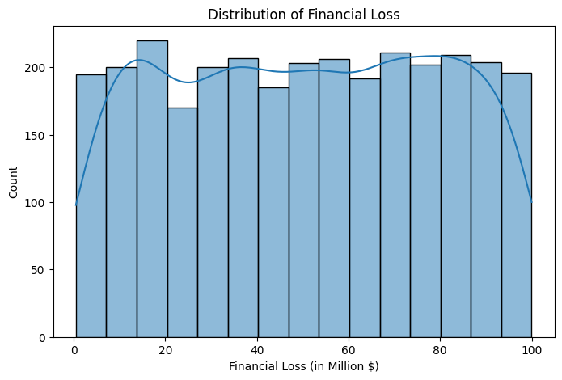
Fig. 1. Distribution of Financial Loss (in Million $)
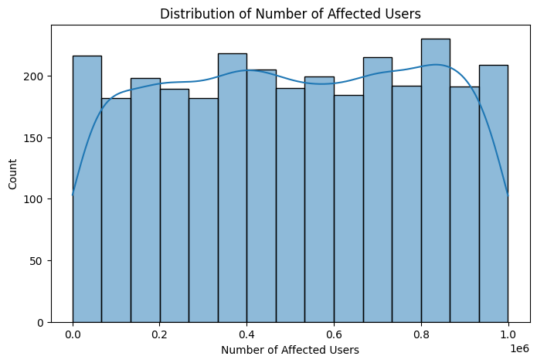
Fig. 2. Distribution of Number of Affected Users
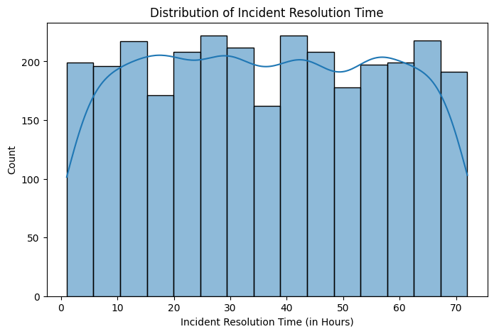
Fig. 3. Distribution of Incident Resolution Time (in Hours)
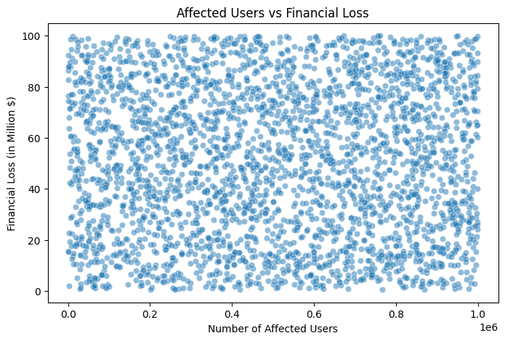
Fig. 4. Scatter Plot: Affected Users vs. Financial Loss
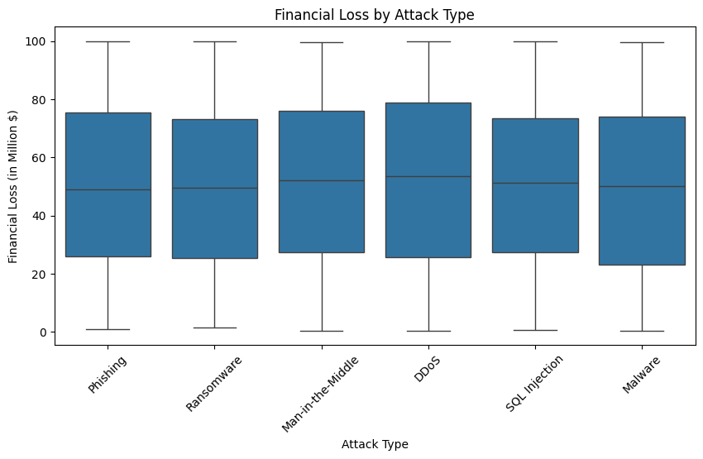
Fig. 5. Boxplot: Financial Loss by Attack Type
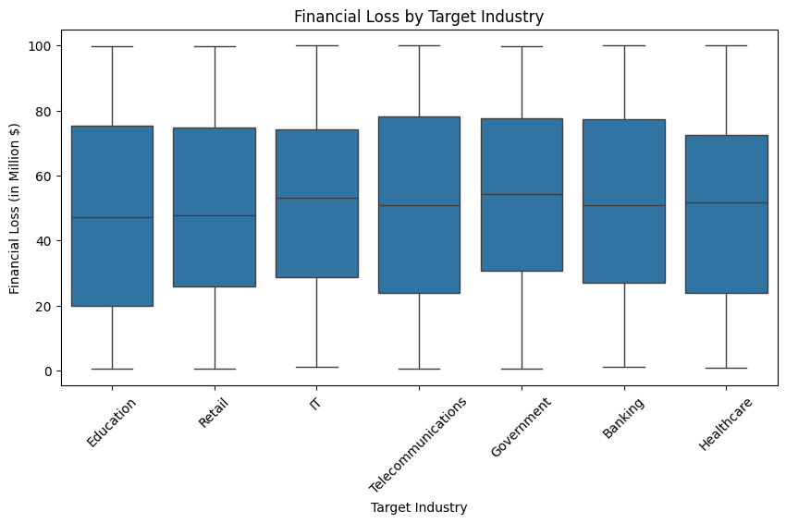
Fig. 6. Boxplot: Financial Loss by Target Industry
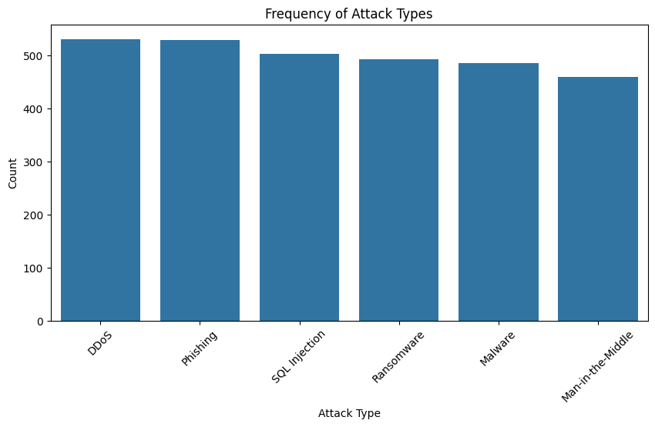
Fig. 7. Frequency of Attack Types
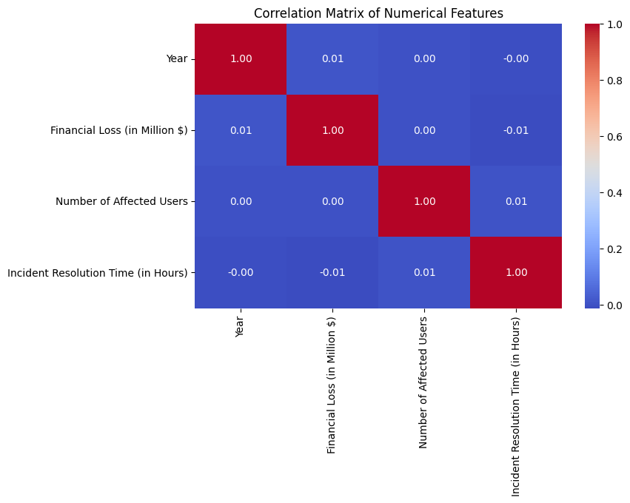
Fig. 8. Correlation Matrix of Numerical Features
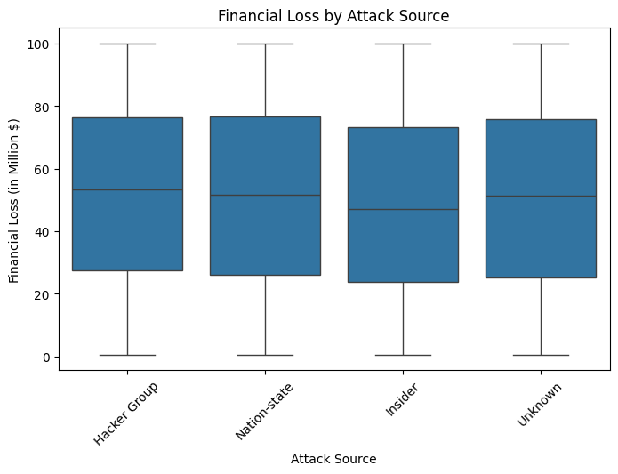
Fig. 9. Boxplot: Financial Loss by Attack Source
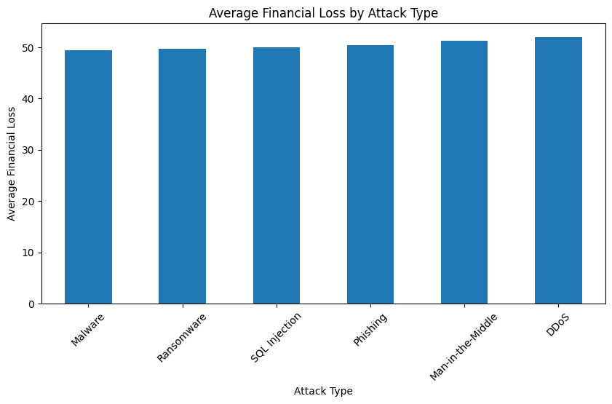
Fig. 10. Average Financial Loss by Attack Type
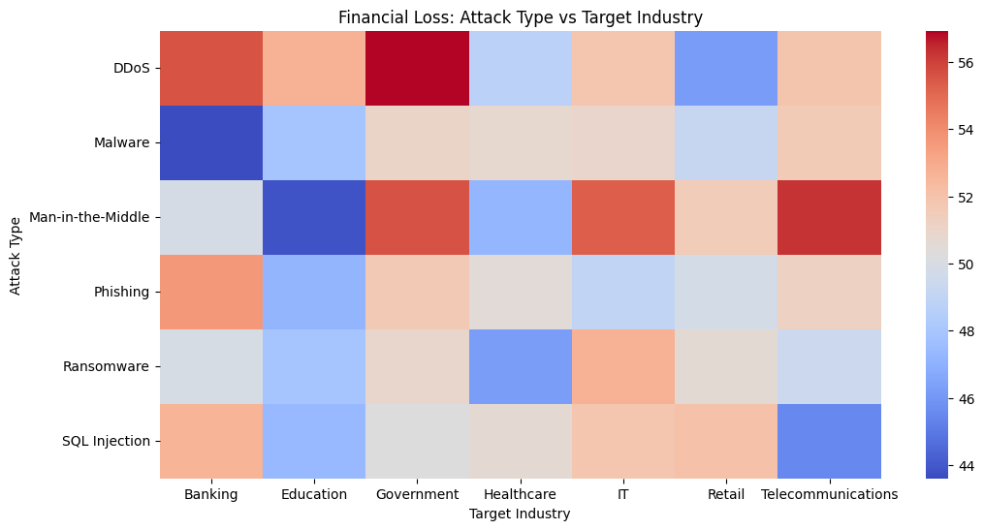
Fig. 11. Financial Loss Heatmap: Attack Type vs. Target Industry
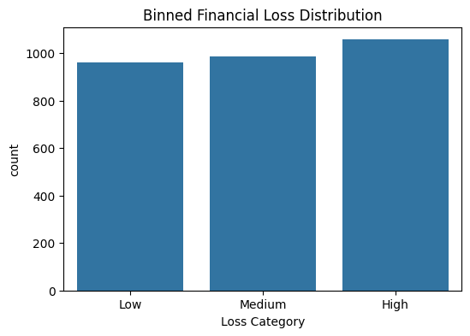
Fig. 12. Binned Financial Loss Distribution (Low / Medium / High)
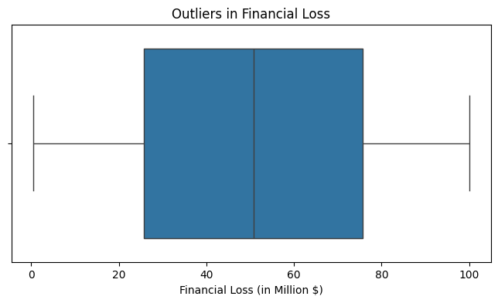
Fig. 13. Outlier Inspection: Financial Loss (Boxplot)
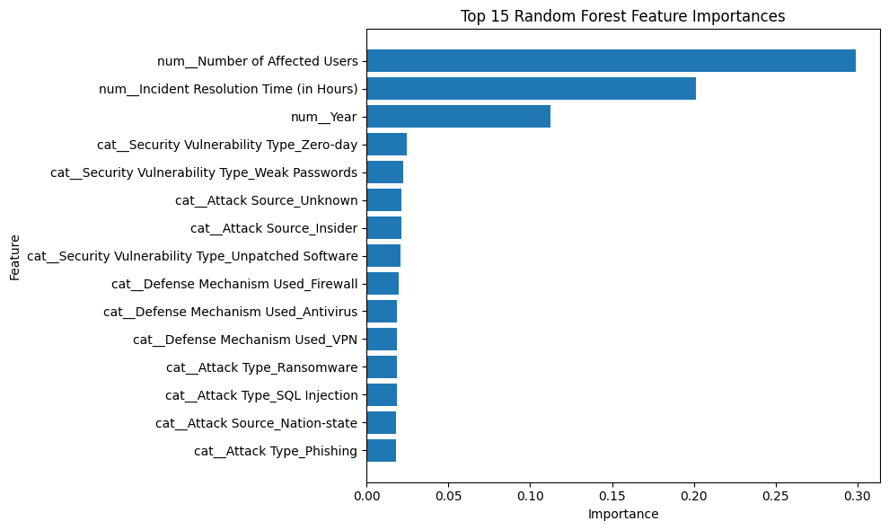
Fig. 14. Top 15 Random Forest Feature Importances
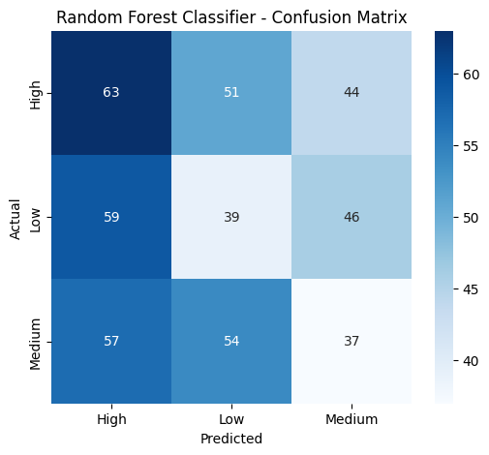
Fig. 15. Random Forest Classifier – Confusion Matrix (Validation Set)
Member Contributions:
- Laith:
  - Project Proposal
  - Data understanding step in notebook
  - EDA step in notebook
  - Data preprocessing step in notebook
  - Baseline model step in notebook
  - Decision tree model implementation in notebook
  - Classification step in notebook
  - Feature Interaction experiment step in notebook
  - Report
- Grace:
  - K-Nearest Neighbour Model in notebook
  - Gradient Boosting Model in notebook
  - Model Analysis in notebook
  - Project Presentation Slides
Gen AI:
We used AI primarily for conceptual clarification and debugging support. Our typical workflow was to first attempt each question ourselves by writing and running our own code and then use AI to review our solutions and identify potential issues or areas for improvement. In some cases, we also asked for explanations of specific concepts to better understand what our code was doing.
A key limitation of using generative AI is that it does not fully understand the specific context or intent of the assignment, including what results are reasonable for a given dataset. As a result, it cannot reliably determine whether outputs are meaningful or aligned with the goals of the analysis. Therefore, we carefully verified all results ourselves, checked assumptions, and interpreted outputs independently rather than relying on AI suggestions without validation.

Repo Link:
- https://github.com/gracenev/DS300Project

IEEE conference templates contain guidance text for composing and formatting conference papers. Please ensure that all template text is removed from your conference paper prior to submission to the conference. Failure to remove template text from your paper may result in your paper not being published.

